Contestant Number: ____________________
Time: ___________________
Rank: _______________



COMPUTER SECURITY
(320)
STATE 2021

CONCEPT KNOWLEDGE:

Multiple Choice (50 @ 10 points each) (500 points)

TOTAL POINTS (500 points)

Test Time: 60 minutes

GENERAL GUIDELINES:
Failure to adhere to any of the following rules will result in disqualification:
- Member must hand in this test booklet and all printouts if any. Failure to do so will result in disqualification.
- No equipment, supplies, or materials other than those specified for this event are allowed in the testing area. No previous BPA tests and/or sample tests (handwritten, photocopied, or keyed) are allowed in the testing area.
- Electronic devices will be monitored according to ACT standards.

- Which type of hacker is considered unethical?
  - White hat
  - Gray hat
  - Black hat
  - Gold hat

- The security triad of CIA forms the basic building blocks for any security initiative. What does the acronym CIA stand for?
  - Commerce, integrity and accuracy
  - Confidentiality, information and availability
  - Commerce, information and accuracy
  - Confidentiality, integrity and availability

- Individuals who usually follow the law but will also venture over the line and do unethical things like hacking are called _____.
  - White hat
  - Gray hat
  - Black hat
  - Suicide hackers

- Which hacker group believes that hacking and defacing websites can promote social change?
  - White hat
  - Gray hat
  - Black hat
  - Hacktivists

- Hackers that perform a security test on a network to determine what an outsider can access and subsequently take control over are known as _____.
  - high-level security analysis
  - network evaluation technician
  - penetration tester
  - suicide hacker

- What layer of the OSI model is commonly the home of malicious applications such as viruses, worms and Trojan horse programs?
  - Transport layer
  - Session layer
  - Presentation layer
  - Application layer

- What security concerns are known to happen at the Transport layer of the OSI Model?
  - Synchronize attack
  - Denial of service attack
  - Buffer overflow
  - All of the above

- File Transfer Protocol is a ________ service and operates on ports _________.
  - TCP, 20-25
  - UDP, 20-25
  - TCP, 20/21
  - UDP, 20/21

- What program allows users to establish a session with a host on a remote site that is not secured?
  - SSH
  - Telnet
  - TFTP
  - Kerberos

- Which protocol utilizes the handshake process, but is less reliable and offers faster delivery speeds?
  - TCP
  - UDP
  - SMTP
  - POP3

- What is the private address range of a class B IPv4 Address?
  - 10.0.0.0 – 10.255.255.255
  - 172.0.0.0 – 172.31.255.255
  - 192.168.0.0 – 192.168.255.255
  - None of the above

- What command will yield the output below? 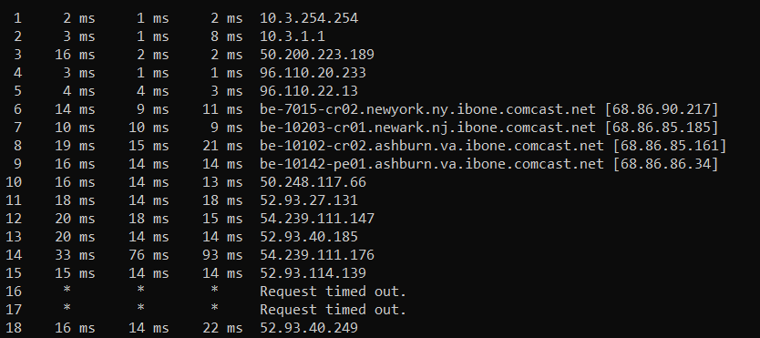
  - Nebstat
  - Arp –a
  - Tracert
  - Ping

- Which of the following is the single greatest threat to network security?
  - Email phishing
  - Insecure physical access to network resources
  - Employees
  - Weak passwords

- Refer to the exhibit below. How is the traffic from the client web browser being altered when connected to the destination website of www.cisco.com?
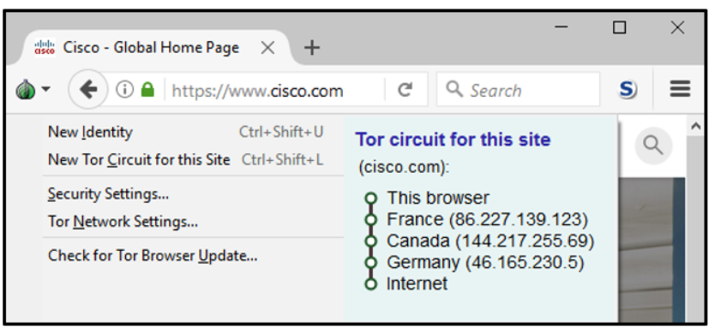
  - Traffic is encrypted by the user machine and sent directly to the cisco.com server to be decrypted.
  - Traffic is sent in plain-text by the user machine and is encrypted by the TOR node in France and decrypted by the TOR node in Germany.
  - Traffic is encrypted by the user machine, and the TOR network encrypts next-hop information on a hop-by-hop basis.
  - Traffic is encrypted by the user machine, and the TOR network only routes the traffic through France, Canada, Germany, and delivers it to cisco.com.

- Which type of cryptography mechanisms hides secret communications with various forms of data?
  - Algorithm
  - Ciphertext
  - Steganography
  - Cryptanalysis

- Which tool would be used to examine and validate the bandwidth on your network and allow the network administrator to identify when the bandwidth is significantly below than what it should be?
  - Packet sniffer
  - Protocol analyzer
  - Load tester
  - Throughput tester
- When an intrusion has been detected, what aspect is crucial in evidence gathering?
  - Continue monitoring the intrusion
  - Backup all log files and audit trails
  - Restore damaged data from back media
  - Let the user gain access to the compromised system

- When conducting a forensic investigation after an attack is completed, what actions should be performed first?
  - Turn off the infected system
  - Stop all running processes
  - Document and information that is on the screen
  - Remove the hard drive

- When examining a cloned hard drive to that of the original hard drive collected as evidence, what method can be used to verify that the bit-level image copy of the clone matches that of the original hard drive?
  - File directory listing
  - Photographs
  - Serial number notation
  - Hashing

- Which of the following is an example of a strong password?
  - Bat9io45a
  - Robert694
  - Desktop#7
  - Ta8b11$i

- As packets traverse a network, the time to live is decremented by 1. If the time to live field becomes 0 before it reaches its destination, what is the direct result?
  - All packets are returned to the sending system
  - Packets are dropped and a message is returned to the sending system using IMAP
  - Packets are dropped and a message is returned to the sending system using ICMP
  - The TTL in regenerated and the packets are forwarded to the next hop

- Switches are a layer 2 network device. Switches forward frames to the next network device based on its _____.
  - IP Address
  - MAC Address
  - Both IP Address and MAC Address
  - None of the above

- IPV6 addresses are how many bits long?
  - 32 bytes
  - 32 bits
  - 128 bytes
  - 128 bits

- Which port number is associated with HTTP?
  - 25
  - 80
  - 443
  - 1024

- What protocol resides at the Internet layer and is used for diagnostics purposes?
  - SNMP
  - ICMP
  - LDAP
  - SUNRPC

- Hackers who use social engineering attacks gain access by _____.
  - using IPsec
  - probing open or unused ports
  - eExploiting human nature
  - phishing

- _____ is when hackers trick victims into providing confidential information through email or websites that look trust worthy, this is an example of what type of attack.
  - Man-in-the-middle
  - Session hijacking
  - Adware
  - Phishing

- What type of an attack can disable a computer by forcing it to use memory or by overworking its CPU?
  - DDoS
  - Algorithm
  - Man-in-the-middle
  - Buffer overflow

- What type of attack uses many systems to flood the resources of a target, thus making the target unavailable?
  - DoS
  - DDoS
  - Spoofing
  - Ping Sweep

- Which method helps to ensure data integrity?
  - Privacy
  - Authorization
  - Hashing
  - Repudiation

- What methods are used to ensure confidentiality?
  - Encryption and authorization
  - Encryption and authentication
  - Encryption and integrity
  - Encryption and nonrepudiation

- What are two common hash functions?
  - RC4 and MD5
  - SHA and RSA
  - MD5 and RC4
  - SHA and MD5

- What are the components of a comprehensive security policy?
  - Increased accountability for user within the organization
  - Increased accountability for the employers of the organization
  - Increased accountability for both users and stakeholders within the organization
  - Gives network security staff a lesser role in management of security policies

- What is a method of sending information from one device to another using removable media?
  - Walk and carry attack
  - Sneaker net attack
  - Media disturb attack
  - Flashing attack

- A _____ is a malicious code that replicates by independently exploiting vulnerabilities in networks.
  - Virus
  - Trojan Horse
  - Worm
  - DDoS

- A type of attack that takes advantage of system’s vulnerabilities to lock down the system and demand payment to unlock system.
  - Hostage attack
  - Ransomware attack
  - Brute force attack
  - Rootkit attack

- _____ are network devices that are designed to limit or filter network traffic between trusted and untrusted networks.
  - Router
  - Switch
  - Layer 3 switch
  - Firewall

- Traceroute command used within Linux with the –I option uses what types of packets?
  - TCP packets
  - UDP packets
  - ICMP packets
  - TCP and UDP packets

- What method is used to determine firewall vendor, version of software and what services are running?
  - Tunneling
  - Banner grabbing
  - Honeypots
  - IDS

- An administrator enables MAC filtering on a WAP. What will be the direct result of this action?
  - MAC address can be spoofed.
  - MAC address cannot be spoofed.
  - MAC filtering will limit the number of IP addresses that can access the WAP.
  - MAC filtering will prevent unauthorized devices from accessing the WAP.

- A type of attack that uses a collection of zombie computer systems under control of a hacker is _____.
  - SQL injection
  - DNS attack
  - Botnet
  - Session hijacking

- Which attack steals cookies that are used to authenticate users?
  - SYN Cookies
  - CSRF
  - Cross-site scripting (XSS)
  - Wrapping

- What script will a network administrator use to encrypt passwords on a Cisco Switch or Router?
  - Encrypt password
  - Service password-encryption
  - MD5
  - Enable password encryption

- What class fire suppression system would you need for an electrical fire?
  - Class A
  - Class B
  - Class C
  - Class D

- Two-factor authentication requires all of the below answers except?
  - Something you know.
  - Something you have.
  - Something you borrow.
  - Something you are.

- Which authentication factor involves “something you are?”
  - PIN
  - Smart card
  - Username and Password
  - Fingerprint

- This attack allows hackers to overcome a switch’s segmentation and eavesdrop on all local communication?
  - ARP poisoning
  - Network-jamming attack
  - Authentication flood attack
  - Man-in-the-middle attack

- During a session attack, the hijacker focus his attack on _____.
  - OSI Session Layer
  - OSI Transport (TCP) Layer
  - OSI Network (IP) Layer
  - OSI Data Link (MAC) Layer

- Programs that pretend to do one thing but when loaded actually perform another more malicious act are known as _____.
  - Virus
  - Worm
  - Trojans
  - Password sniffing

- Which device in a LAN infrastructure is susceptible to MAC address-table overflow and spoofing attacks?
  - Switch
  - Router
  - Firewall
  - Server

